function Xs = NewtonRoot(Fun,FunDer,Xest,Err,imax)

% NewtonRoot finds the root of Fun = 0 near the point Xest using Newton's method.

% Input variables:

% Fun       Name (string) of a function file that calculates Fun for a given x.

% FunDer    Name (string) of a function file that calculates the derivative of Fun for given x

% Xest      Initial estimate of the solution

% Err       Maxiumum Error.

% imax      Maxiumum number of iterations

% Output variable:

% Xs        Solution

 for i=1:imax

    Xi = Xest - feval(Fun,Xest)/feval(FunDer,Xest);

    if abs((Xi-Xest)/Xest) < Err

        Xs = Xi;

        break

    end

    Xest = Xi;

end

if i==imax

    fprintf('Solution was not obtained in %i iterations.\n',imax)

    Xs = ('No answer')

end

function f=fun(x)

f=x^2-9

function f=der(x)

f=2\*x

Trial>> Xs = NewtonRoot(@fun,@der,-0.1,0.00001,100)

f =

-8.9900

f =

-0.2000

f =

2.0205e+03

f =

-90.1000

f =

502.8856

f =

-45.2498

f =

123.5110

f =

-23.0227

f =

28.7806

f =

-12.2932

f =

5.4811

f =

-7.6108

f =

0.5187

f =

-6.1705

f =

0.0071

f =

-6.0024

f =

1.3855e-06

f =

-6.0000

Xs =

-3.0000

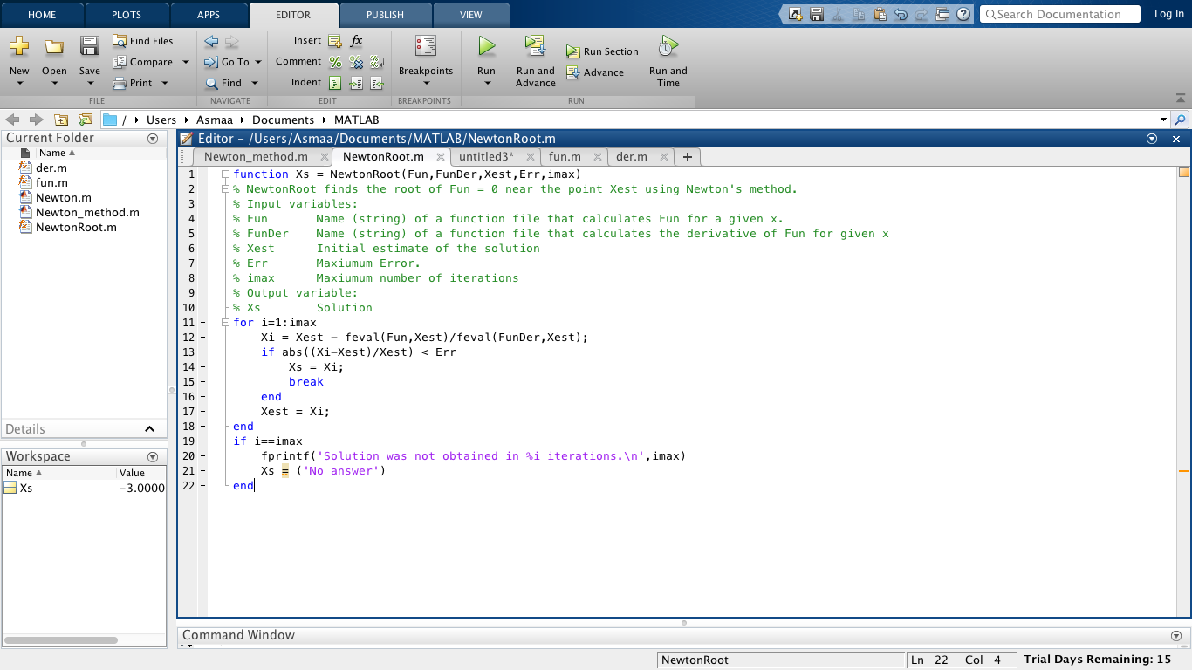

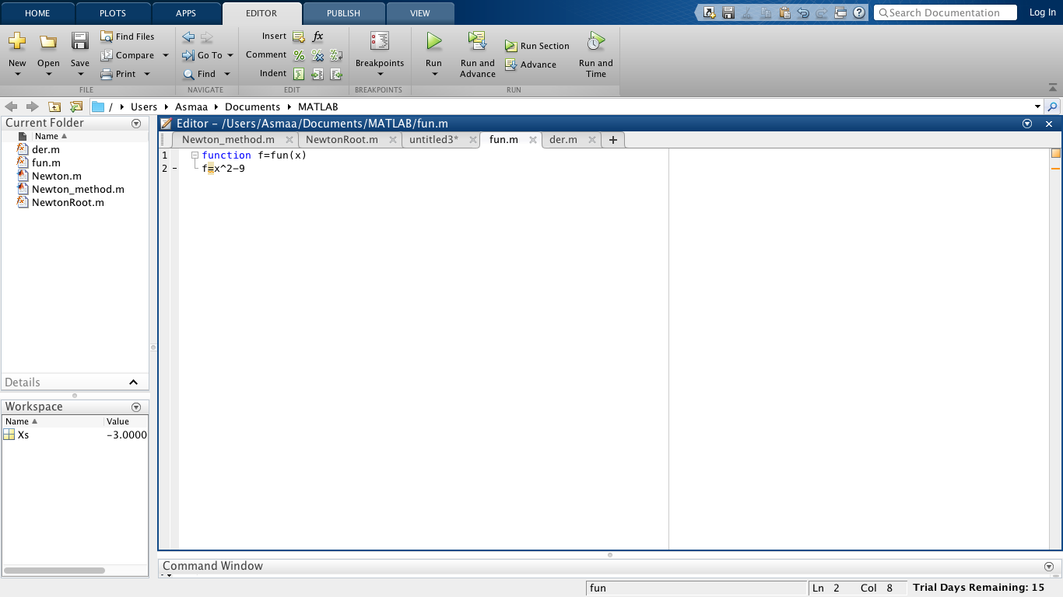

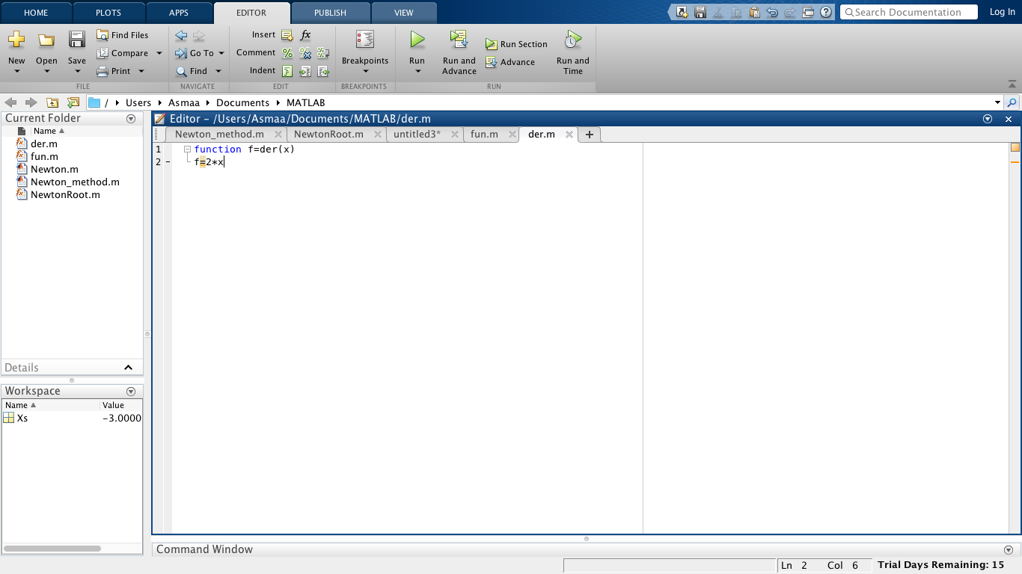

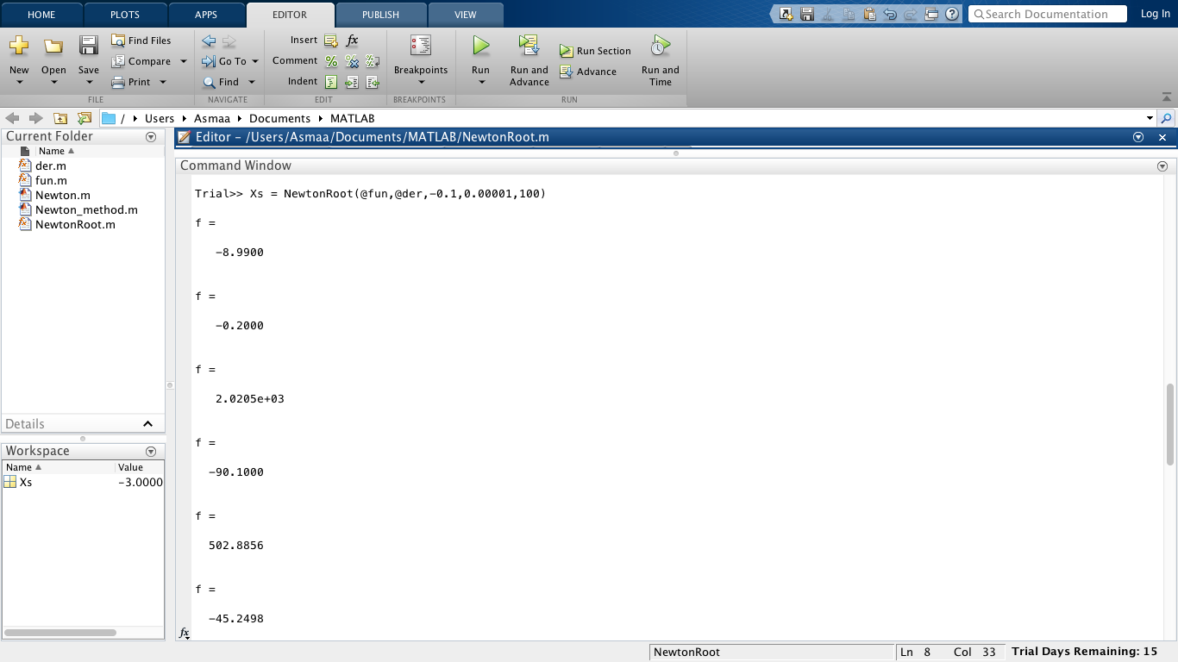

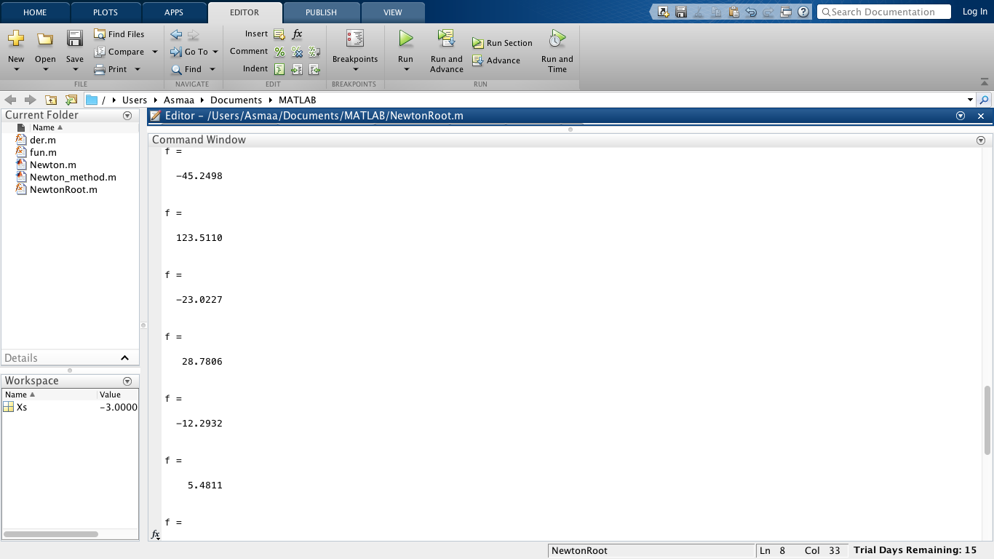

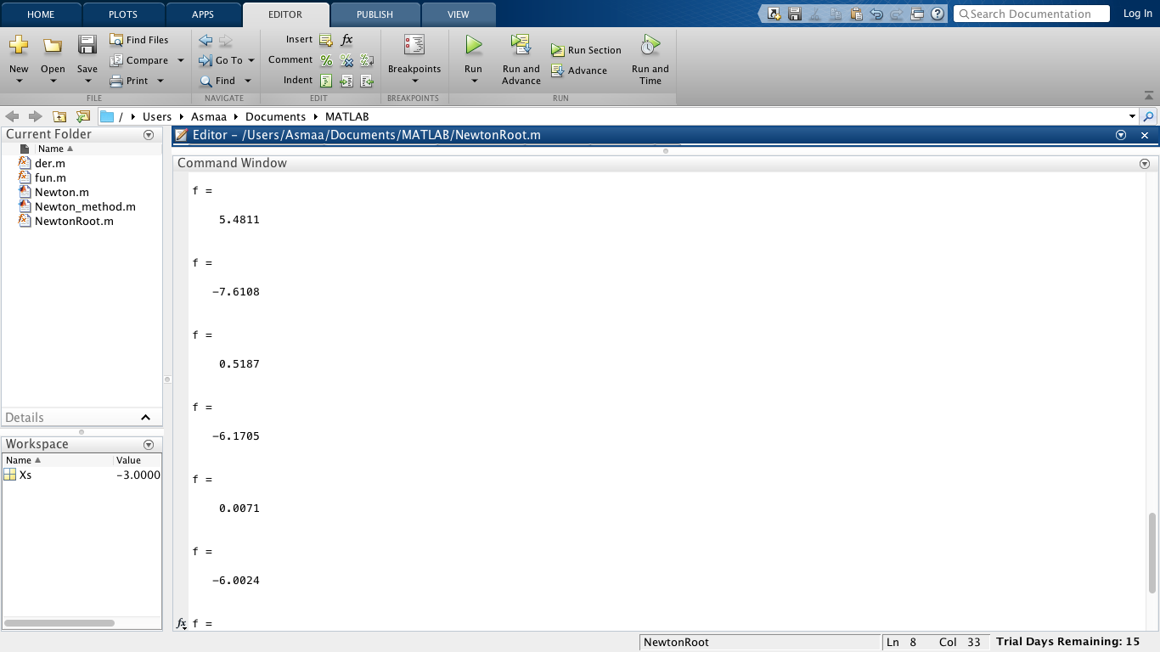

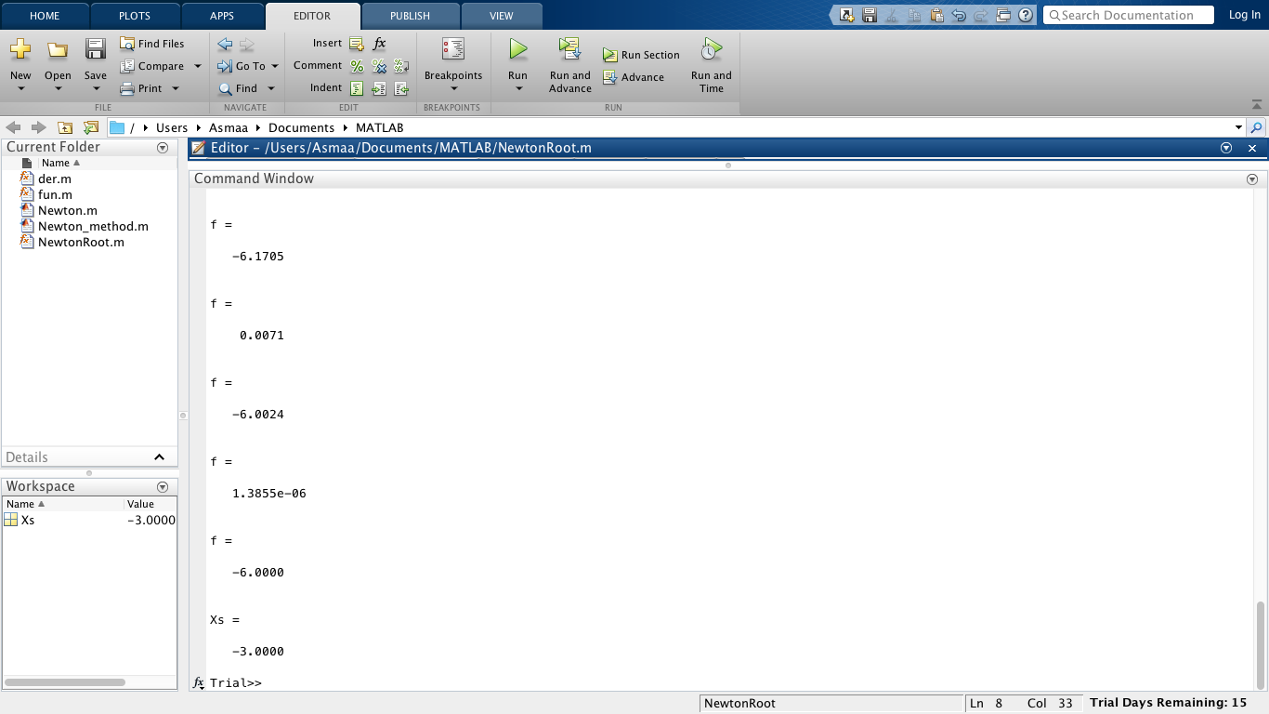

Reference: https://github.com/SpaceShawn/Octave-Matlab/blob/master/NewtonRoot.m